A2 - Network Connections, Wired Connections, and Video Connections

Instructions: Look at the pictures below and write down the name of the connection and its purpose.

1. Network Connection:

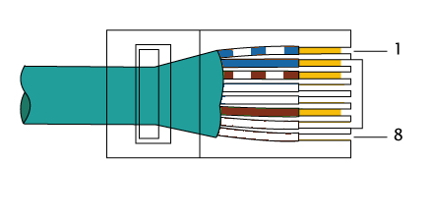]

Name: ______________________

Purpose: ____________________

2. Wired Connection:

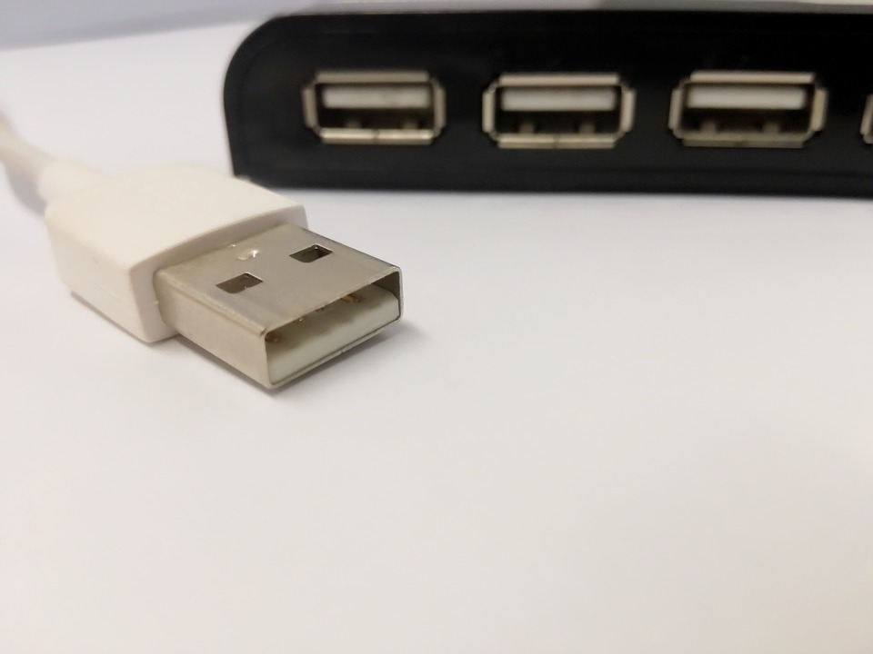

Name: ______________________

Purpose: ____________________

3. Video Connection:

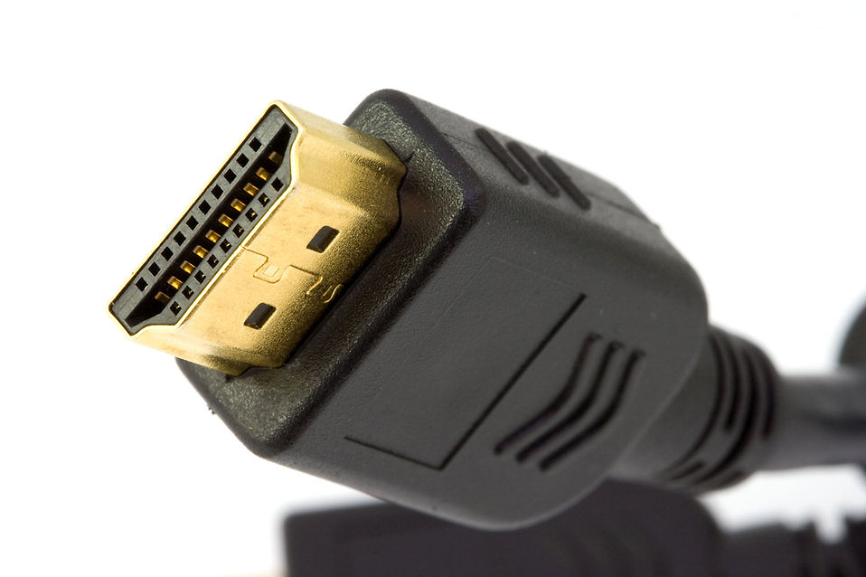

Name: ______________________

Purpose: ____________________

4. Network Connection:

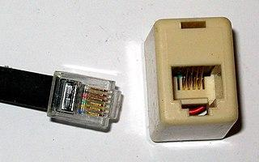

Name: ______________________

Purpose: ____________________

5. Wired Connection:

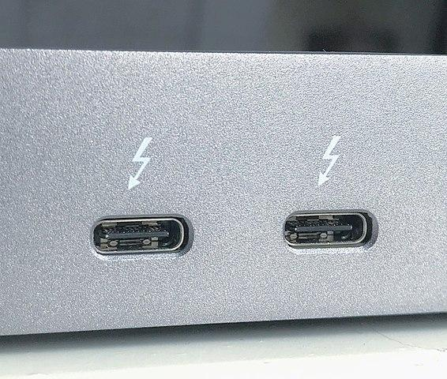

Name: ______________________

Purpose: ____________________

6. Video Connection:

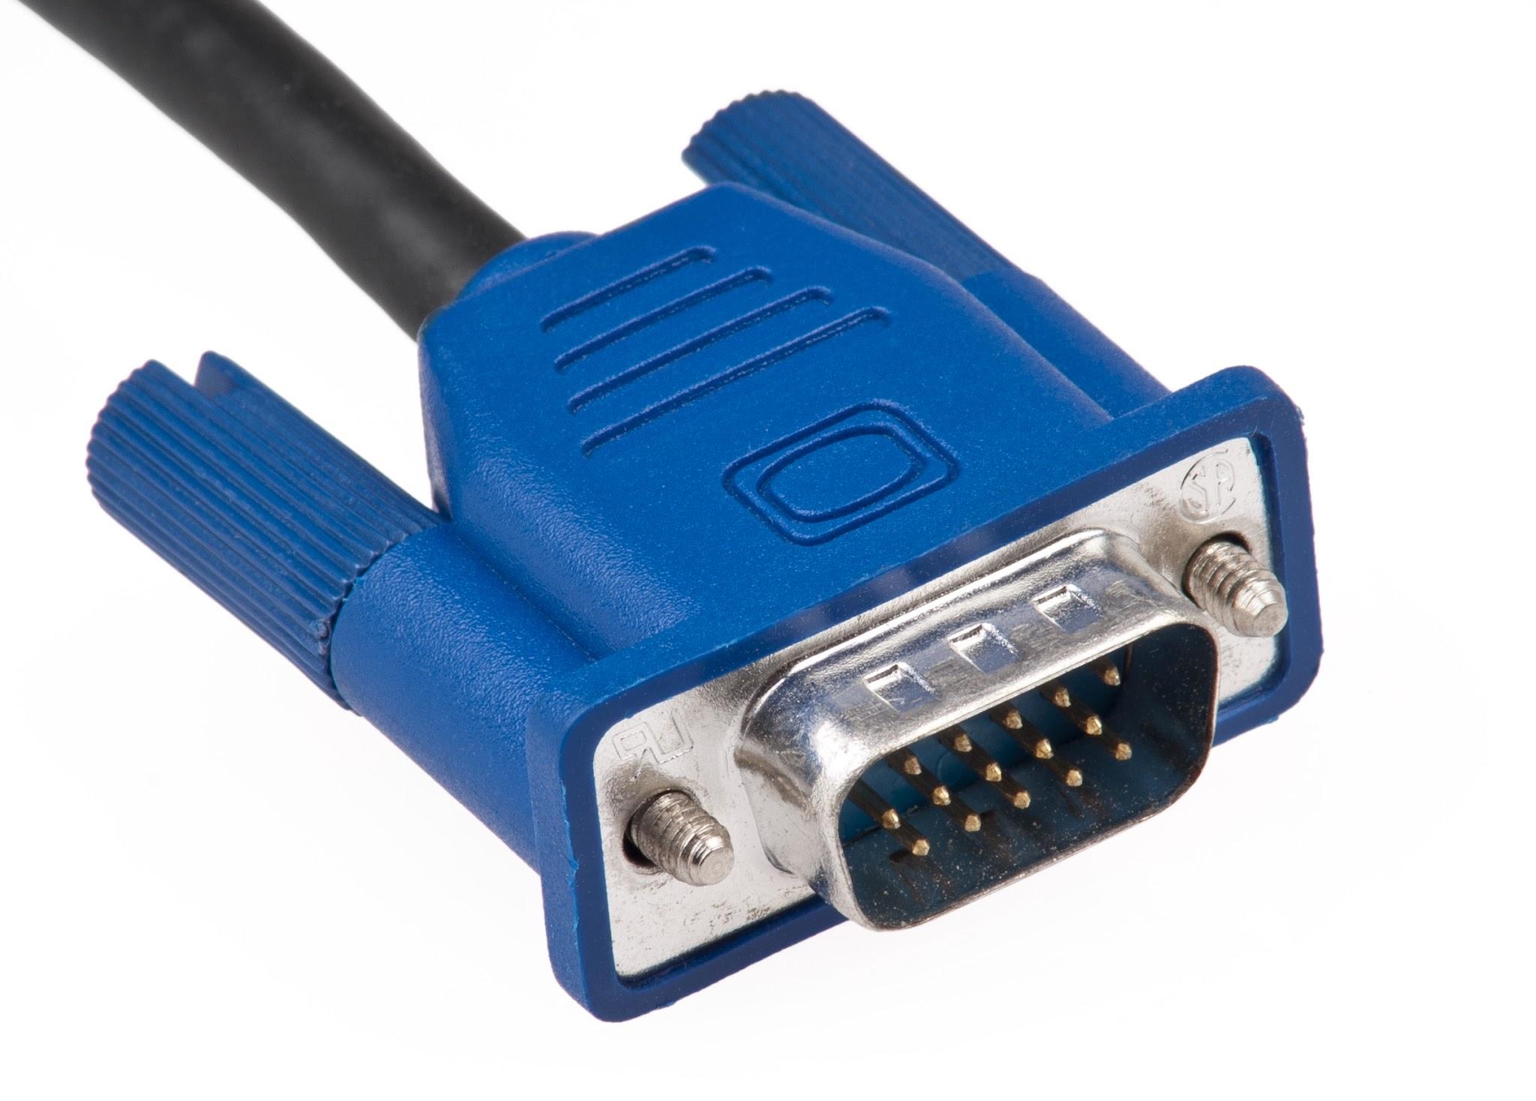

Name: ______________________

Purpose: ____________________

# Activity: Research

Instructions: Research and find examples of network connections, wired connections, and video connections. Create a presentation or poster showcasing the connections you found, including their names, purposes, and where they are commonly used.

Requirements:

- Include at least three examples of network connections, three examples of wired connections, and three examples of video connections.

- Use images and information to describe each connection.

- Present your findings in a clear and organized manner.